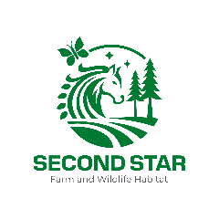

Thank you for joining us at Second Star Farm and Wildlife Habitat! We are very excited about your visit. We want to make sure your trip is as safe and enjoyable as possible, so here are a few tips:

- All visitors must wear closed-heeled, closed-toed shoes (no flip flops, sandals, crocs, slippers or slides). Sneakers or boots are acceptable. Uggs are discouraged. Because this is a farm, there is a good likelihood that your footwear will get dirty. Don’t wear any shoes you can’t clean or want to keep clean.

- Because this is an outdoor activity, long pants are highly recommended. For any child participating in pony rides or lessons, long pants or leggings are required.

- Any child participating in a pony ride or lesson must wear an approved riding helmet. Second Star has loaner helmets available for children’s use.

- Second Star will provide visitors with treats for the horses. If visitors wish to bring their own treats for their pony friends, fresh carrots or fresh apples are appropriate.

- Pony rides and lessons will not be held in temperatures with a real-feel of 95 degrees or hotter, or with real-feel temperatures below 32 degrees. All visits (mounted and unmounted) will be cancelled in the event of lightning, snow, or heavy rains.

- No open umbrellas are allowed. Rain jackets or ponchos are acceptable.

- All visitors are required to sign a liability waiver and “hold harmless” agreement at the beginning of their visit. Visitors under the age of 18 are required to have a parent or guardian signature.

- We treat all creatures on this property with respect. This extends to our pollinator friends – such as bees and wasps – and our ant friends who help maintain healthy soils. Please refrain from purposely squishing them, and opt for natural bug repellents when possible.

- Absolutely no alcohol, smoking, vaping or illegal substances are allowed on the premises.

- If you need to cancel for any reason, please text Christina at 540-841-2142. As a courtesy, we request cancellations occur 24 hours in advance when possible.

